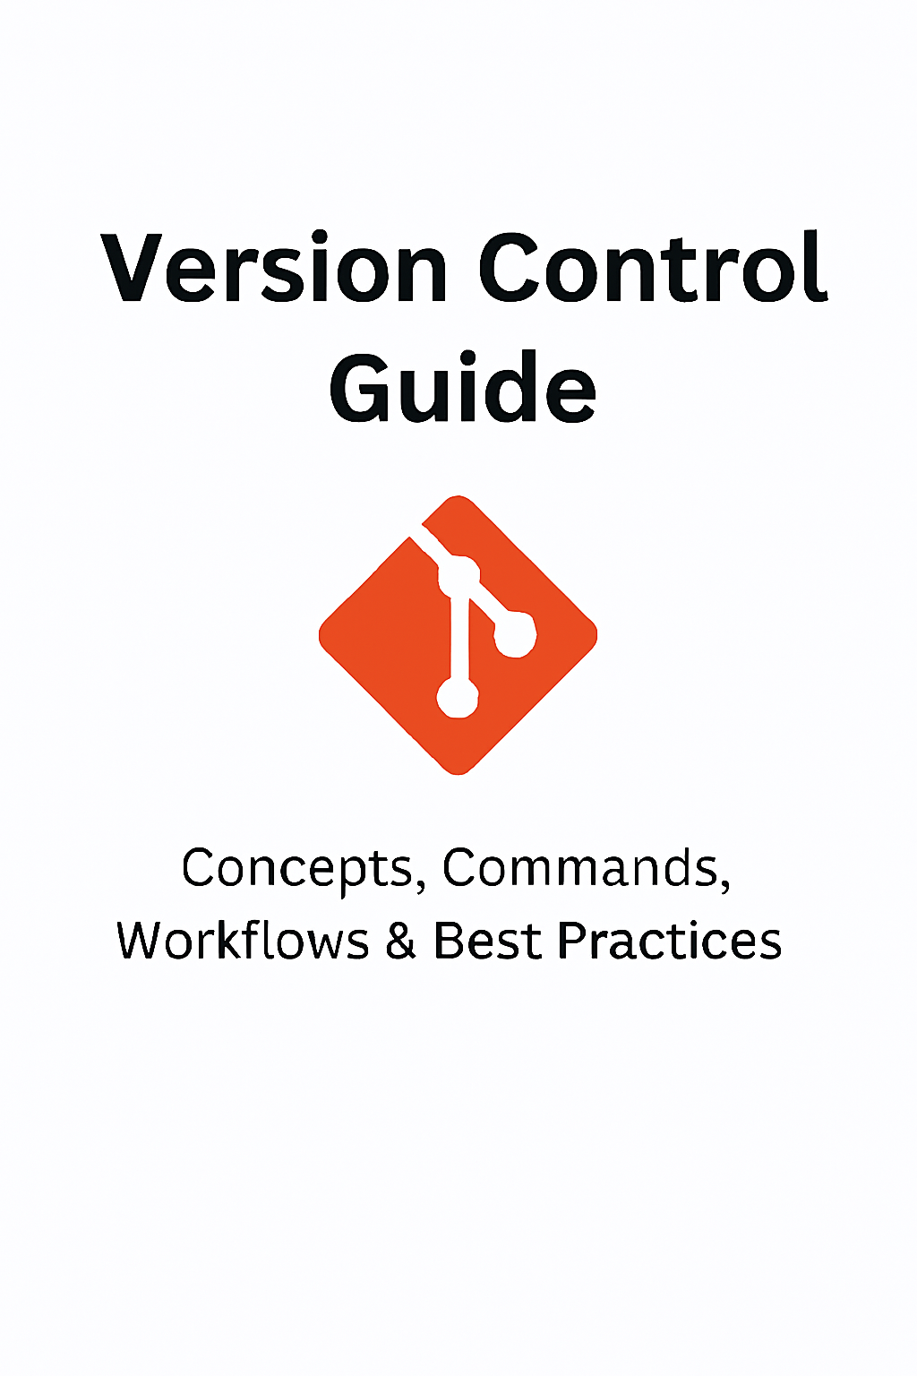

**VERSION CONTROL**

A Version Control System (VCS) is software that helps developers track, manage, and collaborate on source code changes over time.  
It maintains a complete history of modifications.

It is also known as software configuration management.

**Types:**

* Local vcs 🡪 keeps version on your local machines only
* Centralized vcs 🡪 one central server. It is also called client server architecture. It is supported by SVN/subversion, cvs.
* Distributed vcs 🡪 each user has a full copy. It is also called distributed architecture. It is supported by GIT tool, mercurial

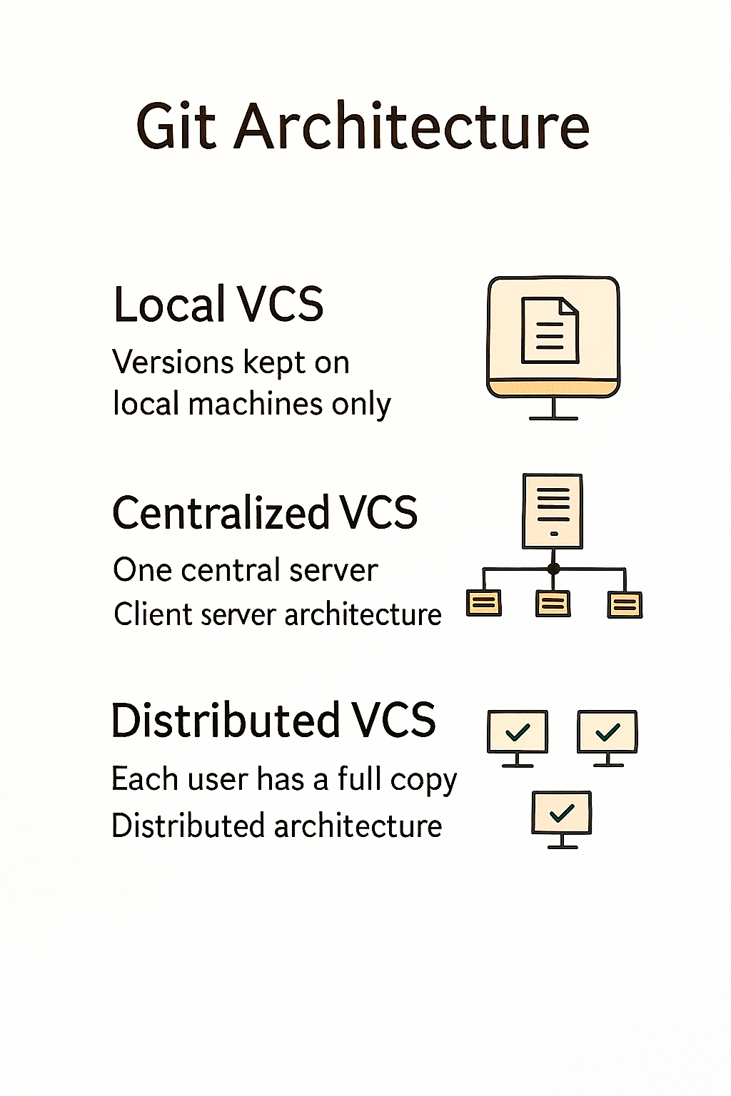

**🧠 1. Git Basics**

Git is a free and open-source distributed version control system to handle everything from small to every large project with speed and efficiency.

**Features:**

* Track versions of source code.
* Rollback to older versions.
* Auto-merge changes.
* Manage customer/release branches.

**Common Commands:**

| Command | Description | Example |
| --- | --- | --- |
| git init | Initialize a new Git repository | git init myproject |
| git clone | Clone an existing repo | git clone <repo-url> |
| git status | Check repo status | git status |
| git add | Stage files for commit | git add file.txt |
| git commit | Save changes to repo | git commit -m "msg" |
| git log | View commit history | git log --oneline |

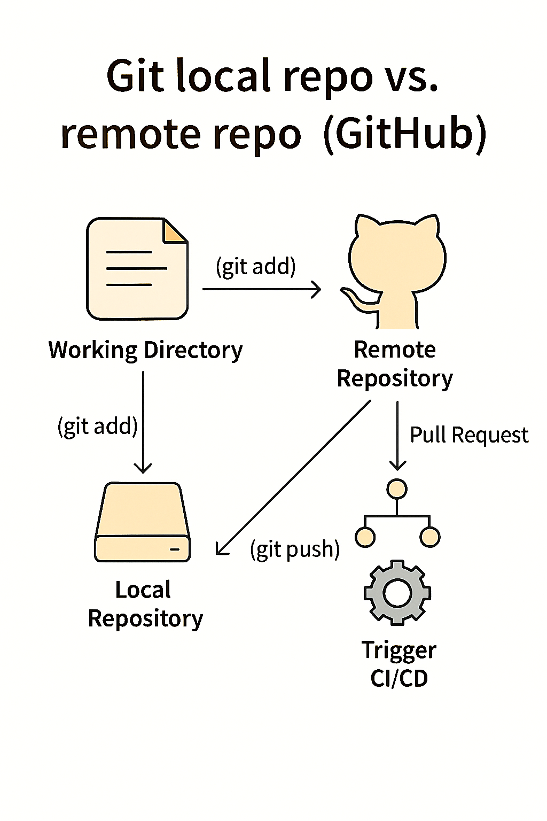

**In vs code without commands, we push to github**

Create a folder on laptop open it with vscode click on terminal 🡪 new terminal 🡪 powershell to bash change

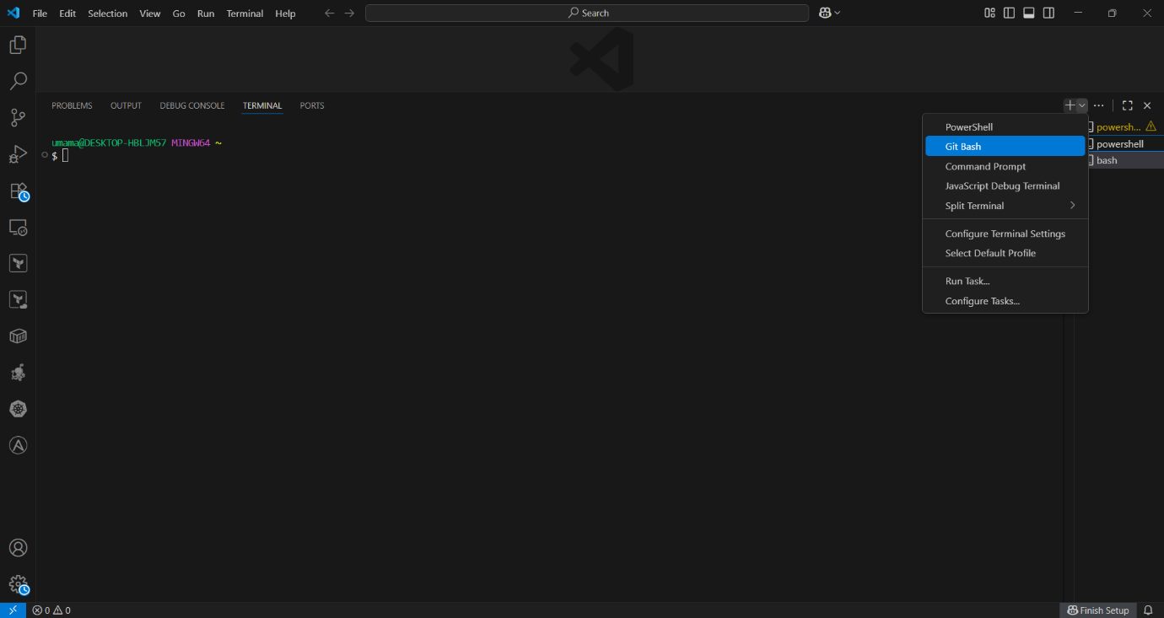

git init 🡪 create a file file.txt 🡪 enter content 🡪save the file

click on source control on vscode left side 🡪 git status we see in red colour 🡪 + click on it in left side it will save changes.

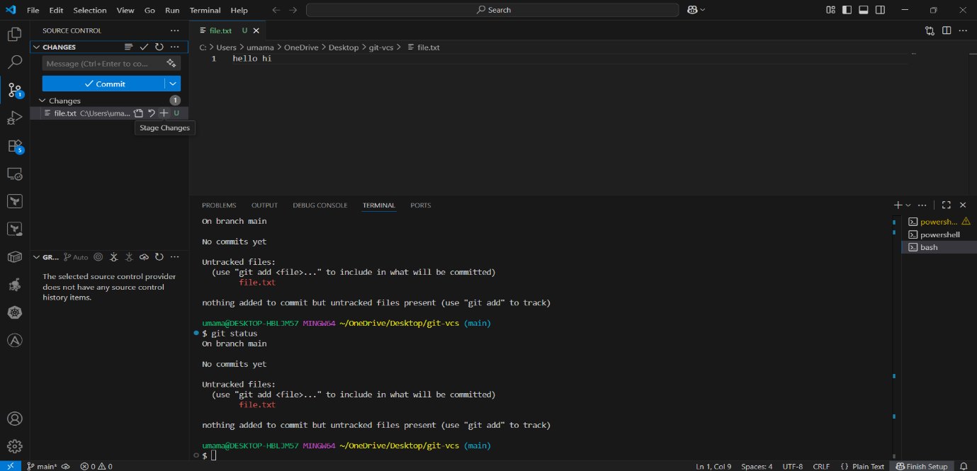

Give commit msg and click on commit

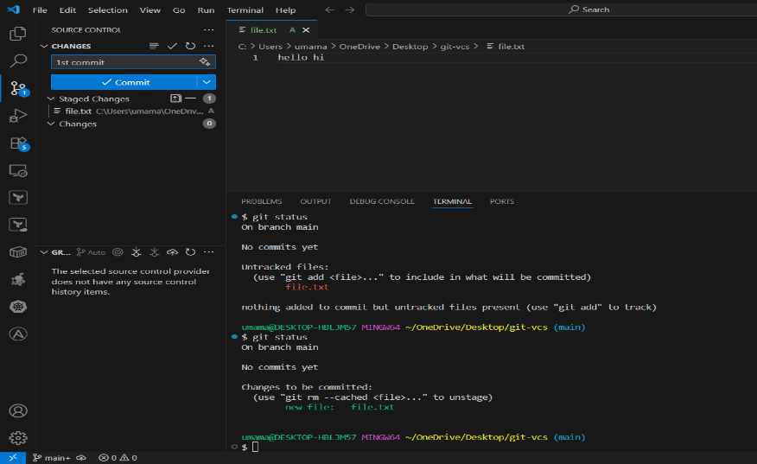

Check git status and git log we see 1st commit there

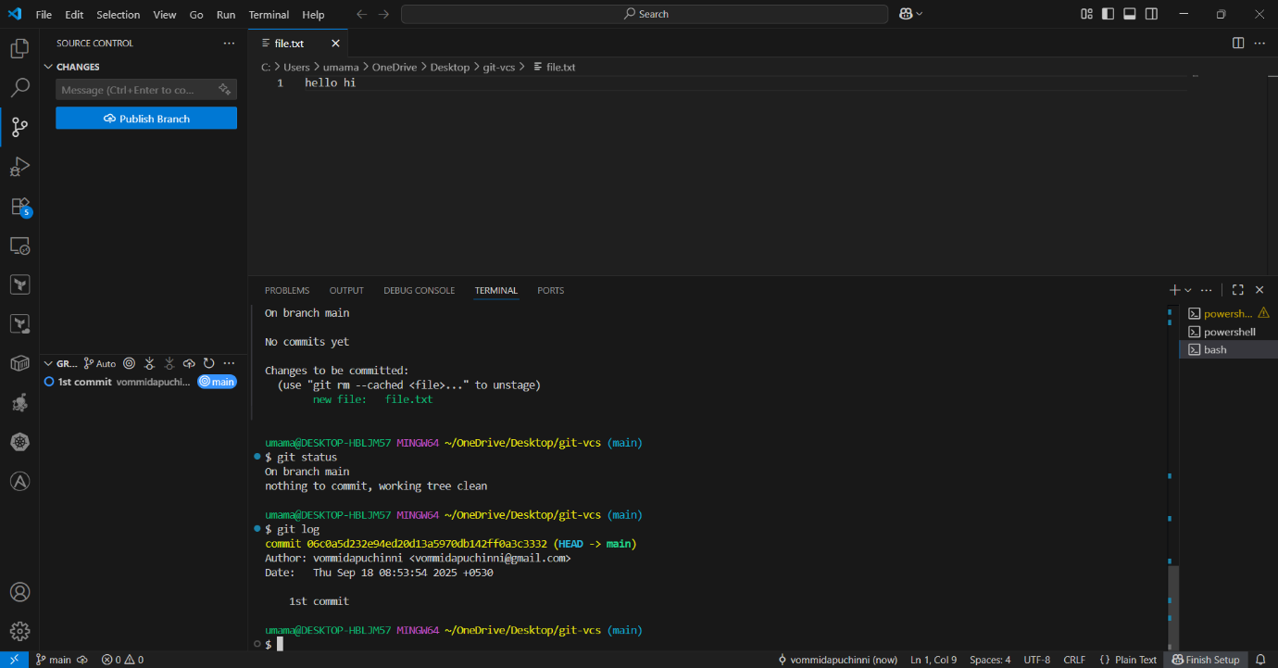

Create remote repo with same folder name

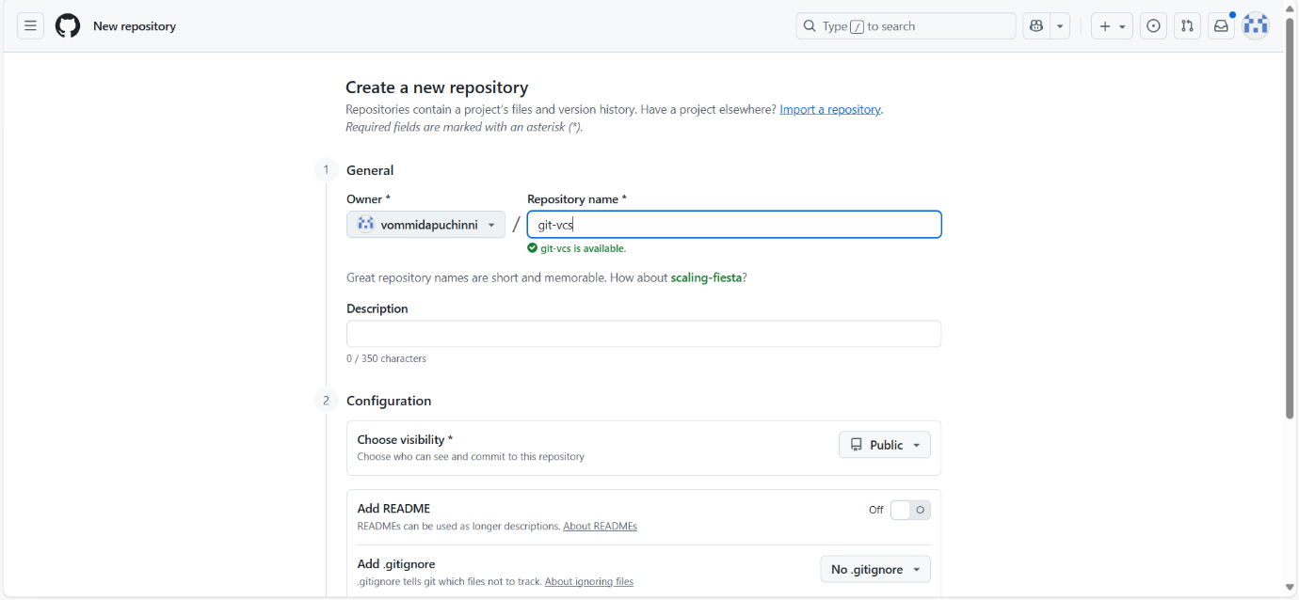

Paste url of remote

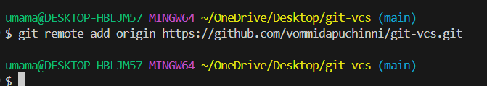

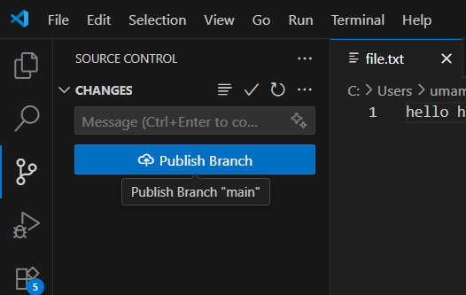

Click on publish branch. In git hub repo we see file is pushed

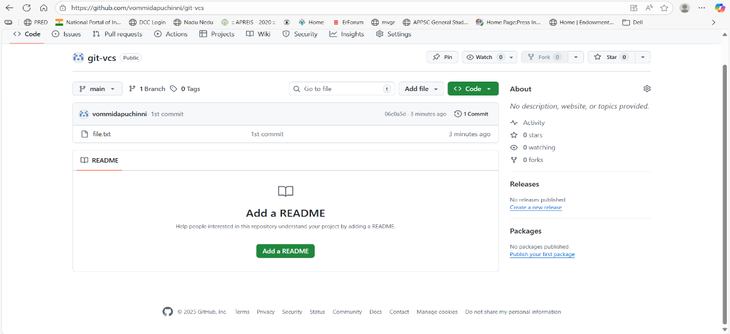

**GitHub Repository Storage**

Every repository uses Git to store data.  
Git compresses and versions files — so each commit adds only changes, not full copies.

**Key Notes:**

* Soft limit per repository: **~1 GB**
* Hard limit per file: **100 MB**
* If you push a file >100 MB → GitHub rejects it
* Repos >1 GB trigger a warning
* Ideal repo size: **<500 MB**

**🌿2. Branching & Merging**

**Definition:** Branches allow multiple lines of development in the same repository.

git branch 🡪 list the branches

git checkout -b dev 🡪 create a new branch and switch to it

data of existing branch is copied to new branch

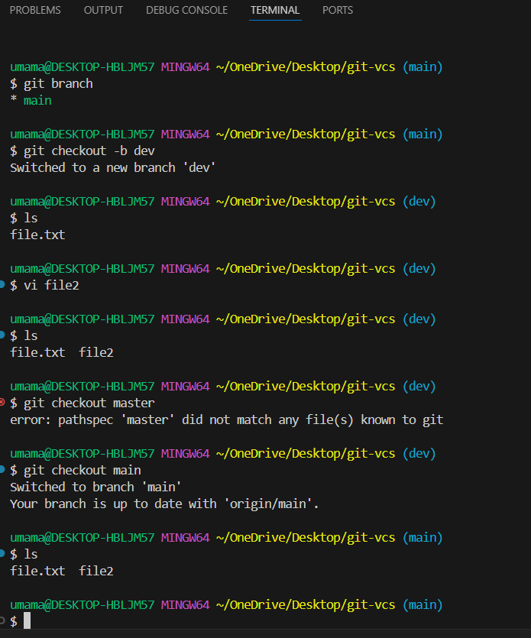

When you commit that file then that data is belongs to that particular branch

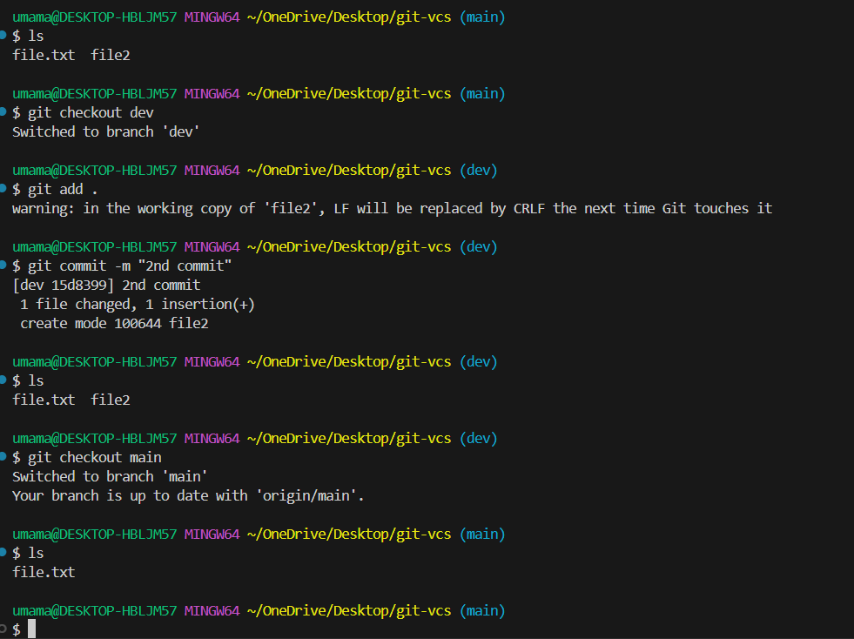

We see 2 commits in dev branch and one commit in main branch

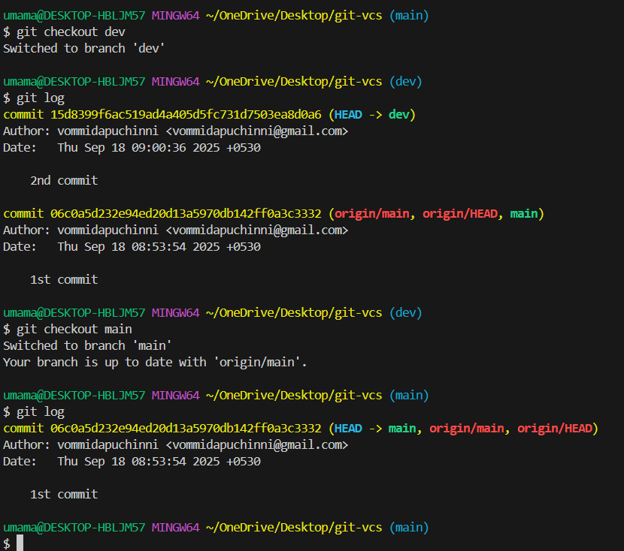

🔀Git merge: Merge another branch into current branch

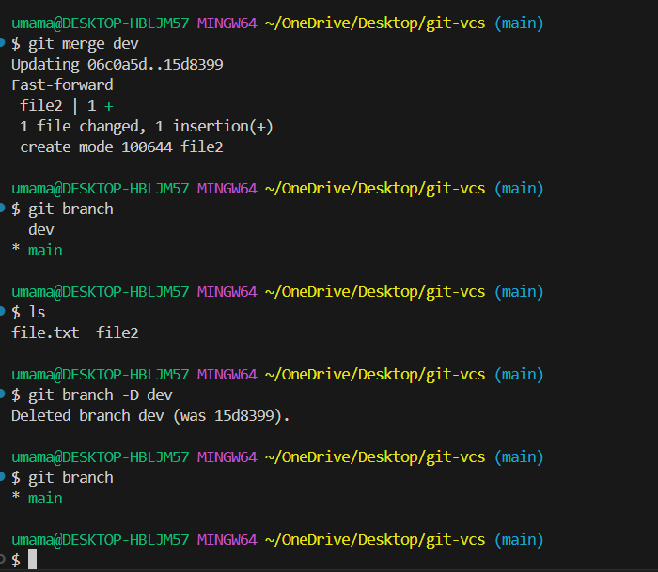

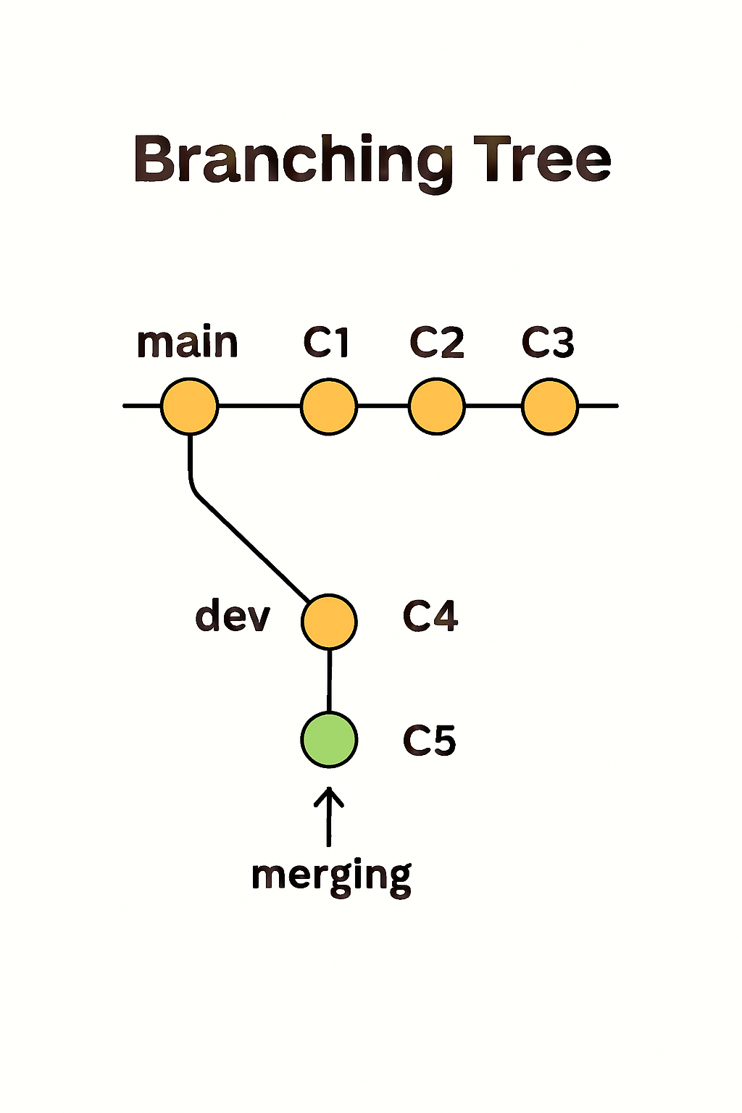

**🍒3. Cherry-pick:** Apply a commit from one branch to another

We have 4 commits in dev branch and moving 3rd commit to the main branch

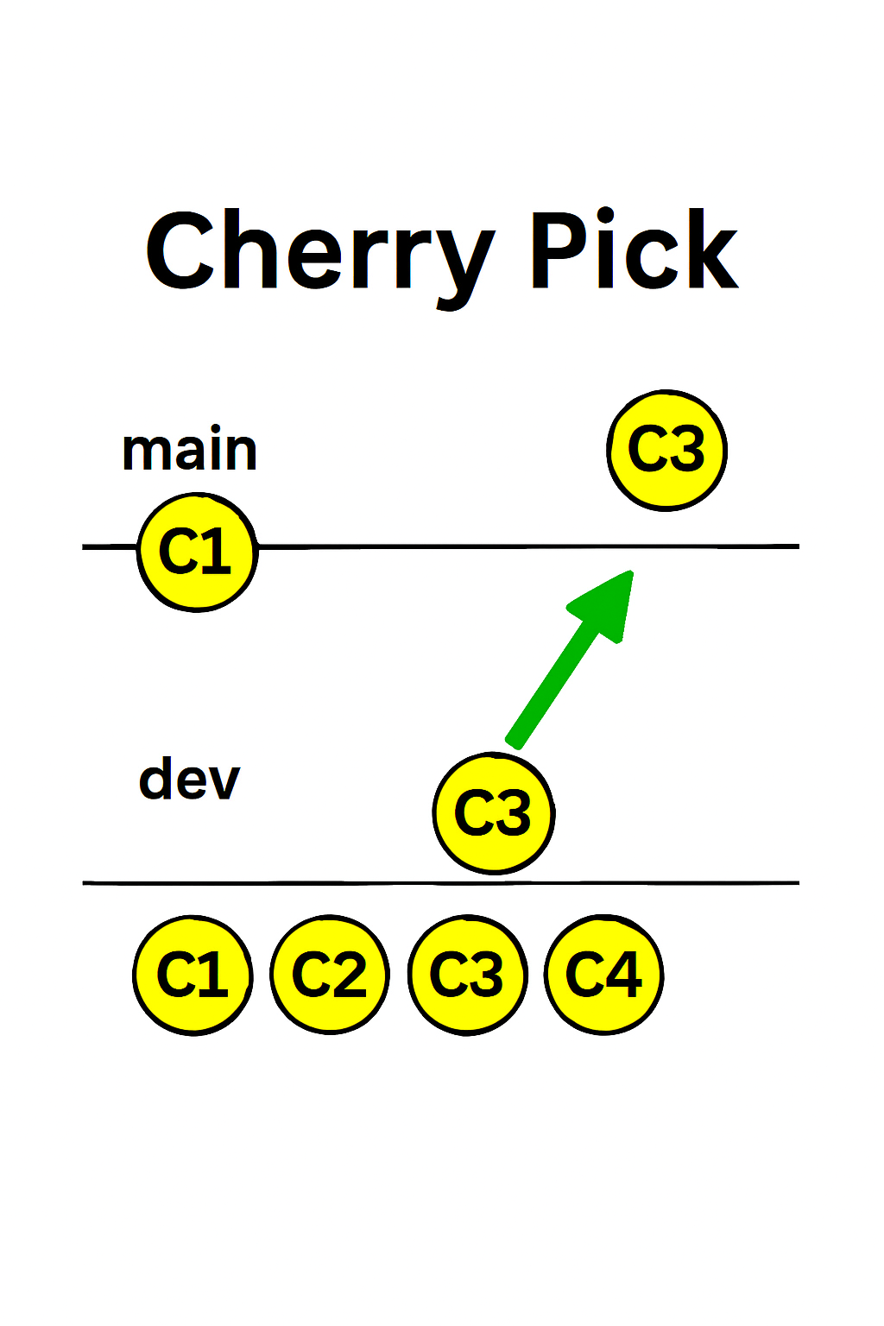

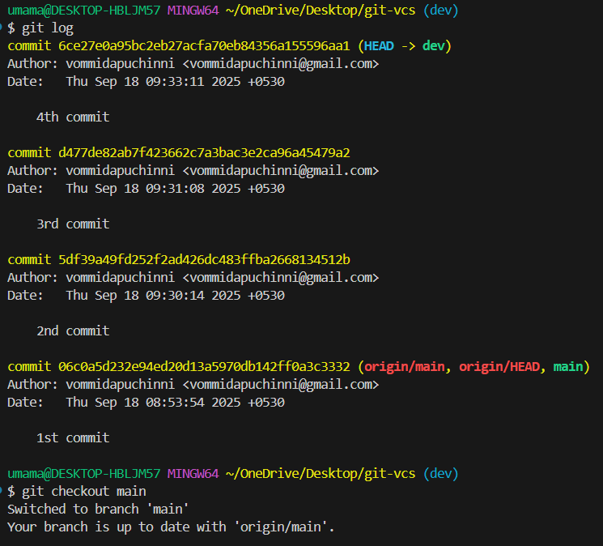

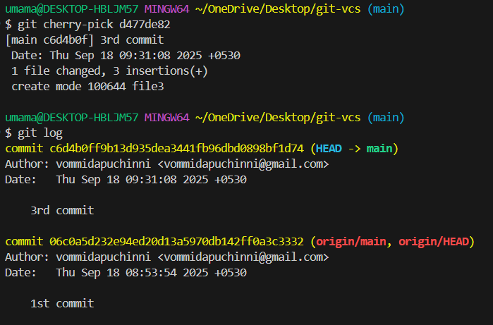

We see 3rd commit in main branch

**🔖 4. Git tag:** Assign a meaning full name with a specific version in the repo

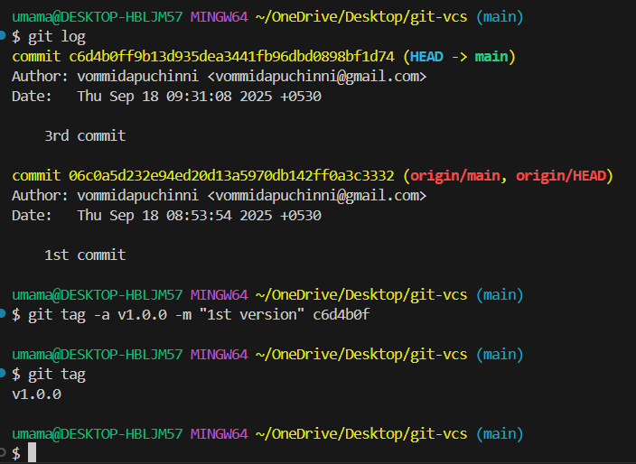

When we push branch then tag will not be pushed separately, we have to push the tag

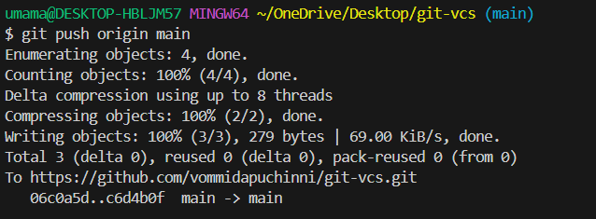

Like this git push origin tag version and We see the tag in git repo

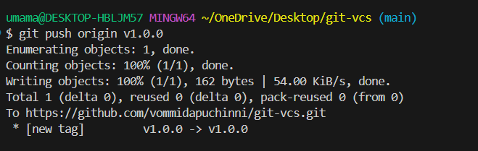 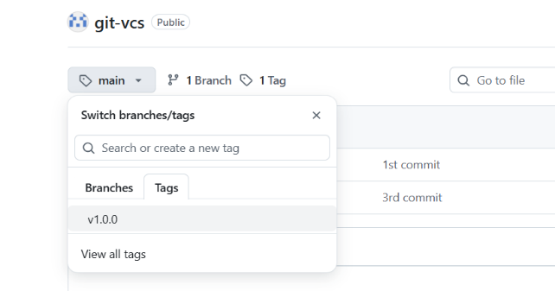

**Undoing Changes**

**🕵️‍♂️ 5. Git reflog:** if we want to recover a deleted branch that was not merged or already merged by using the following command git reflog

Delete the branch 🡪 git branch -D branch name

If we want total data recovery then we use latest head

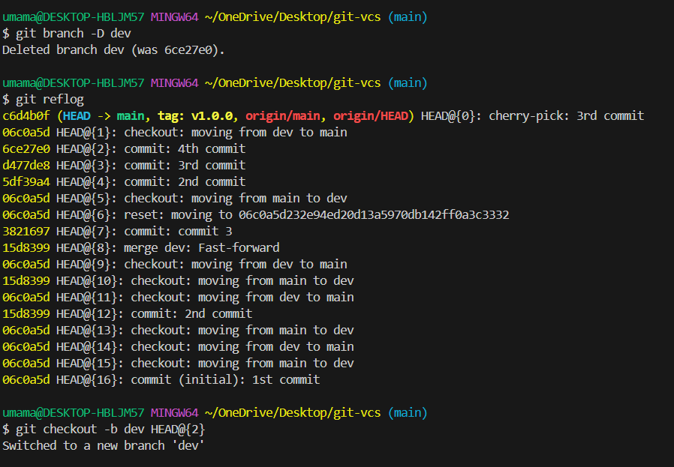

We see all files and commits are recovered. For working together, we have to use collaborators in repo settings

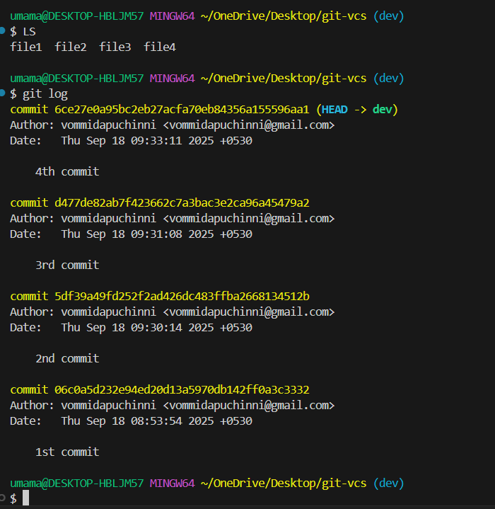

**🔄6. Git reset:** default is mixed

* Create file and add content to it git add and commit it.
* Again, add some content and add and commit it.
* Again, add some data that also add and commit it

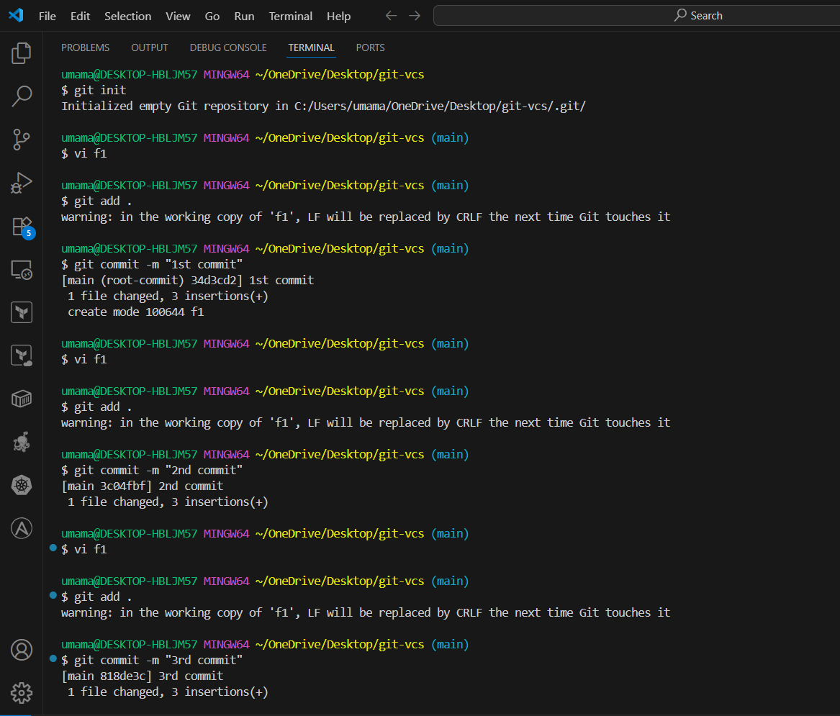

Git log we see 3 commits

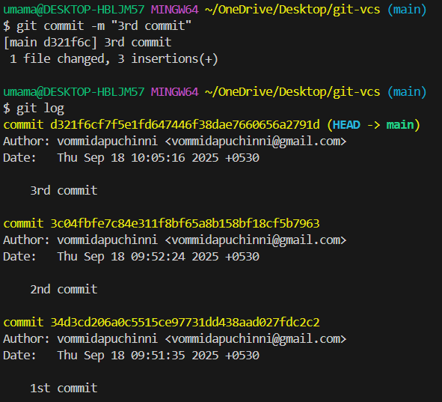

**git reset --soft:** reset data from local repo 🡪 git reset --soft <commit id>

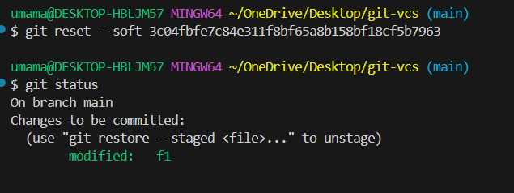

**git reset --mixed:** reset data from local repo, staging area. The mixed option is default.

git reset --mixed <commit id>

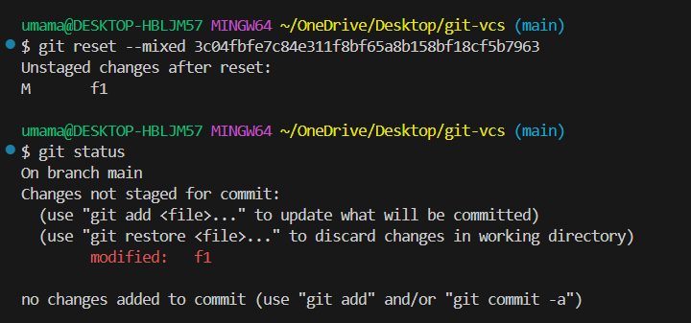

**git reset --hard:** reset data from local repo, staging area and working dir also

git reset --hard <commit id>

we see data is removed

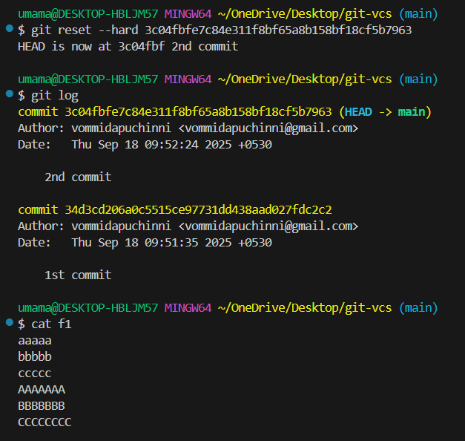

Push those files to remote repo

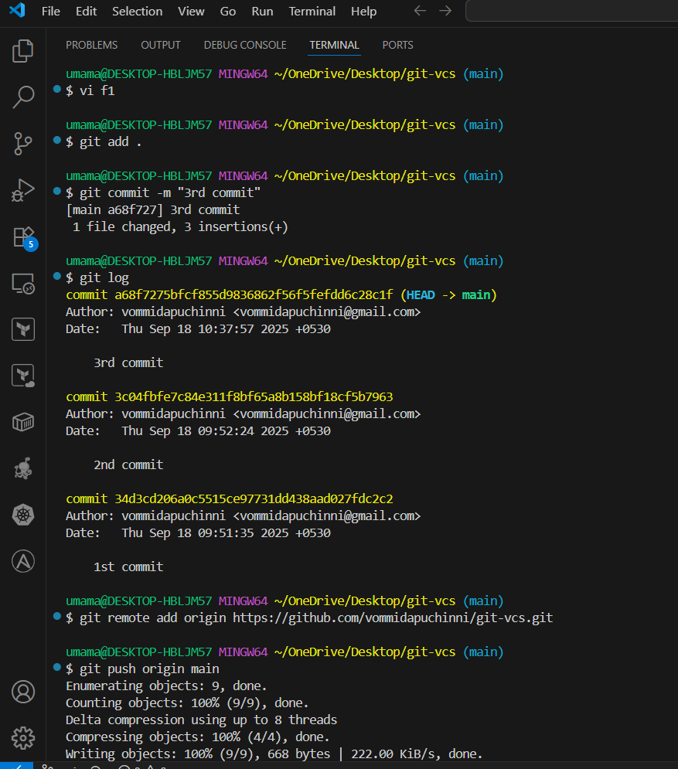

**↩️ 7. Git revert:** Create a new commit that undoes changes

* In f1 add content and push to remote repo
* Copy 3rd commit id
* git revert HEAD <paste 3rd commitid>
* git log we see reverted commit and data is deleted in that file

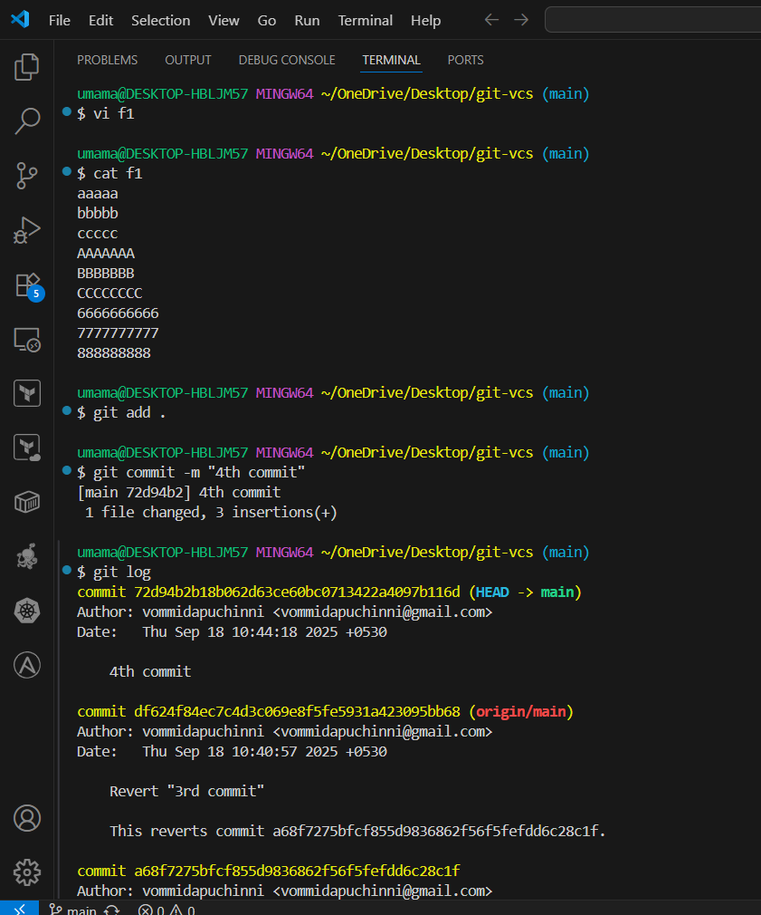

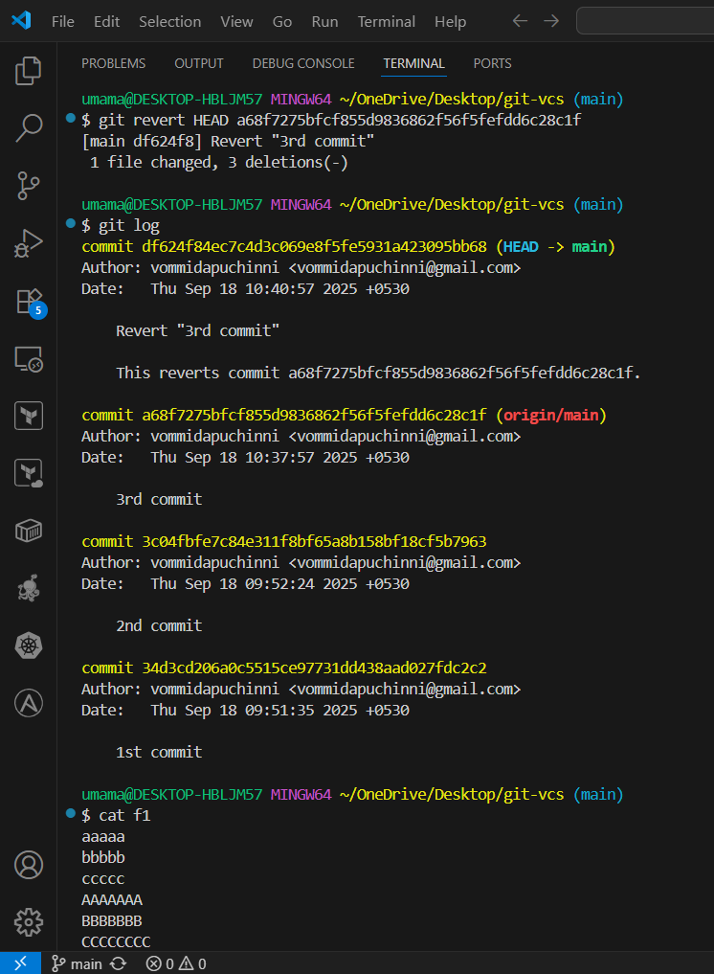

We see number part is deleted in that file

In remote repo also we can see that commit

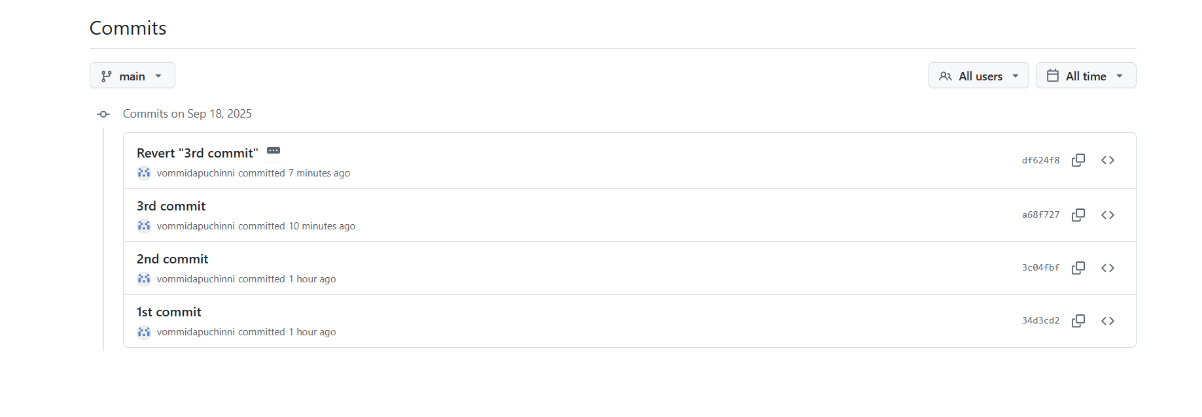

**✏️ 8. Git amend:** If you only want to change the last commit message. Not doing the any other new commit keeping or saving data on previous commit

Open the file f1 and add data to it save, add and commit it.

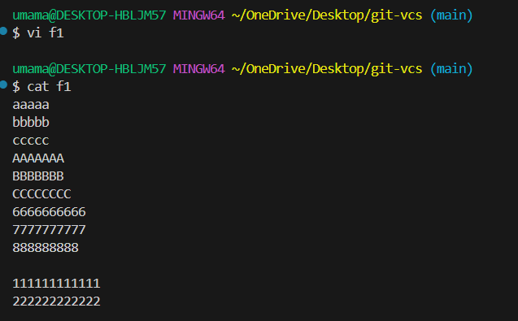

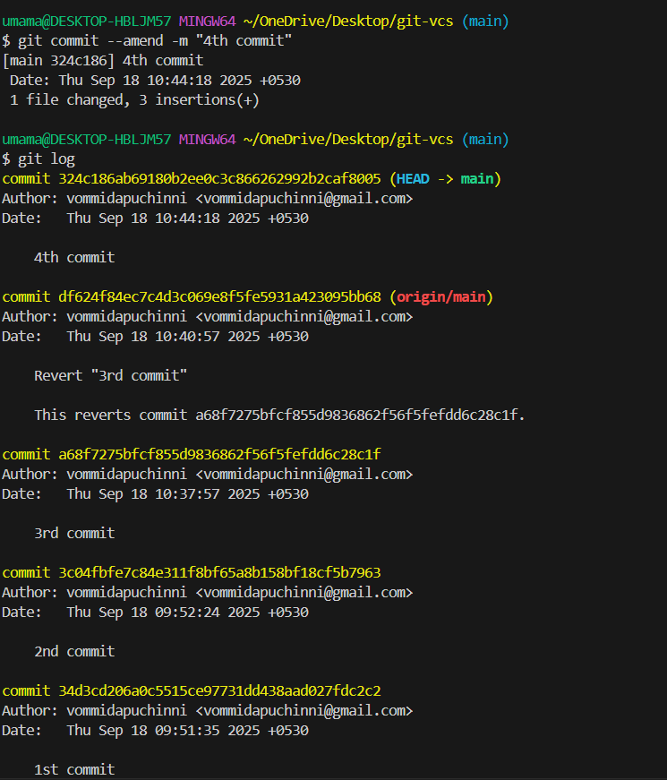

We want to see latest commits we see git log -2

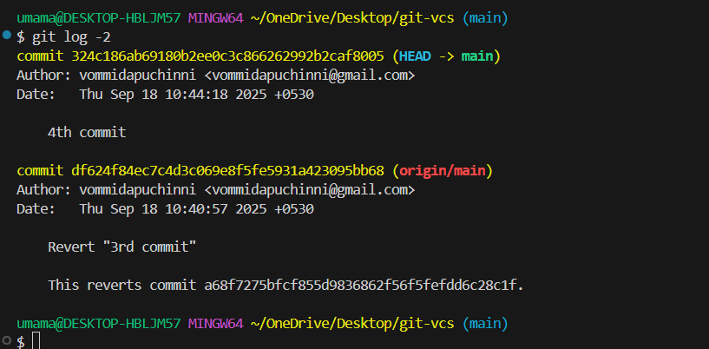

🔍 **9**. Difference between to commits copy the commit ids. We see old line in white and new lines in green and deleted lines in red.

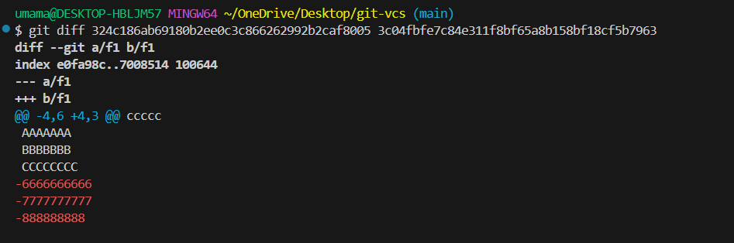

🚫 10. .gitignore: Exclude files from being tracked using .gitignore.

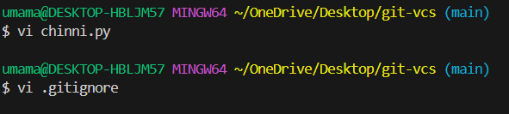

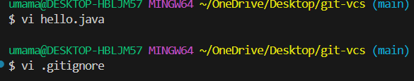

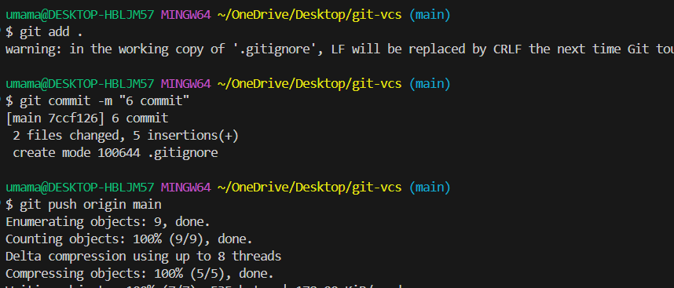

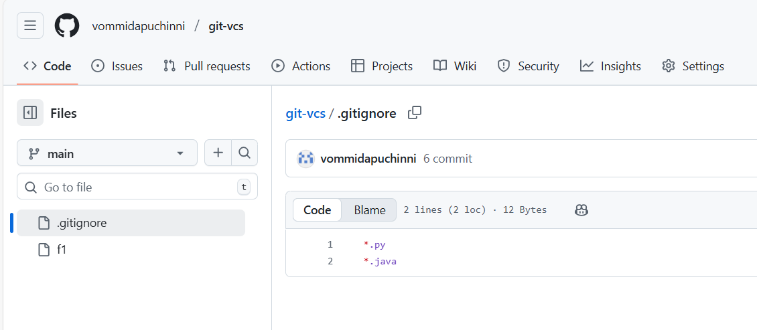

🔄 **11**. git pull = git fetch + git merge

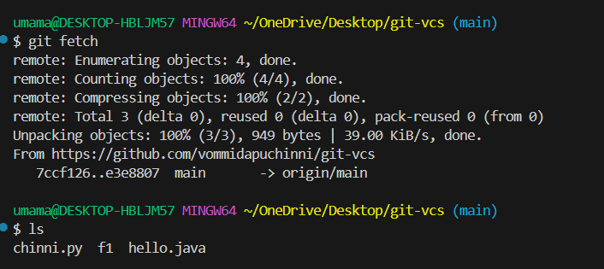

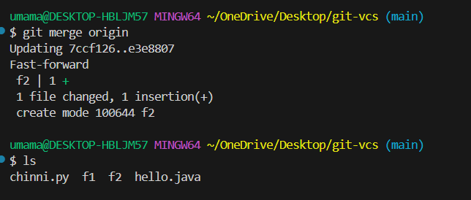

📦 **12.** **Stashing**

**Definition:** Temporarily save uncommitted changes without committing.

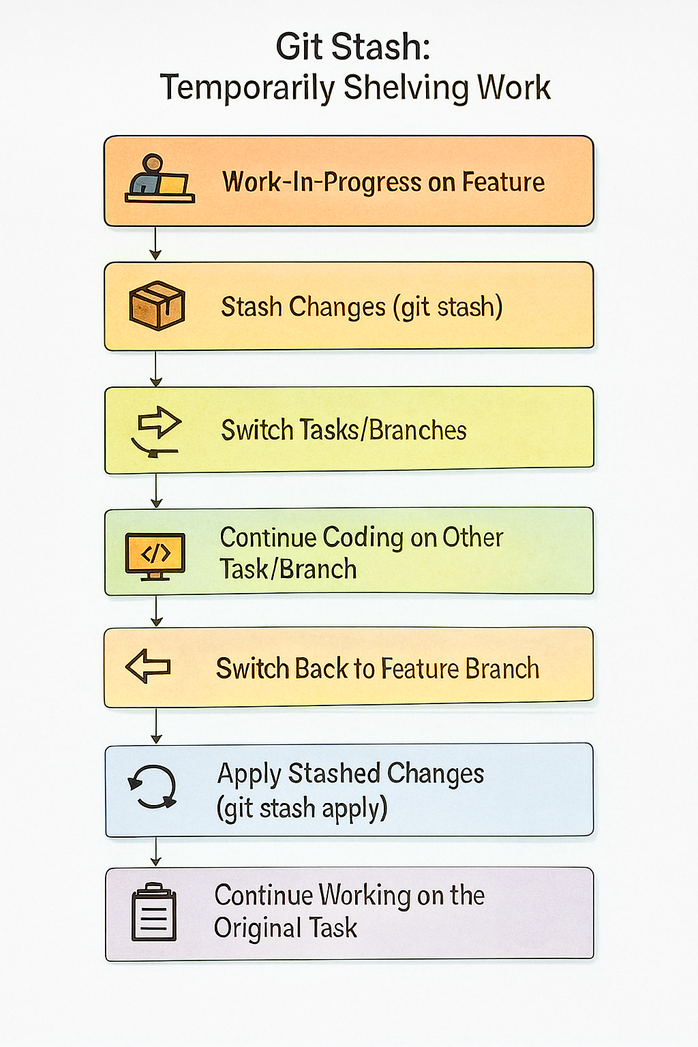

* Create a file f3 and add content to it.
* Save it with git stash save -m “1st stash”
* git stash pop 🡪 cut and paste
* git stash drop 🡪 which stashes are applied those are deleted
* git stash clear 🡪 clear all stashes
* git stash list 🡪 list stashes we see

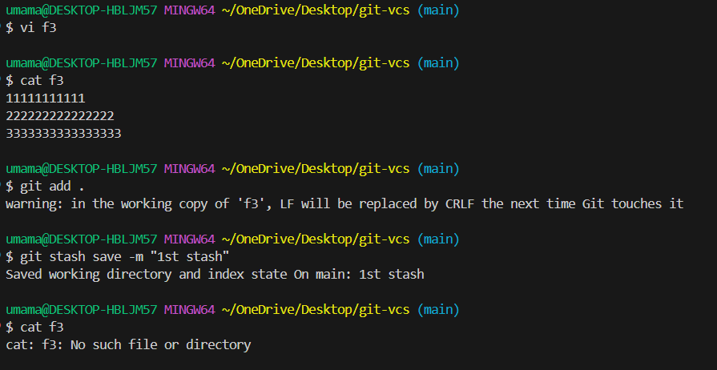

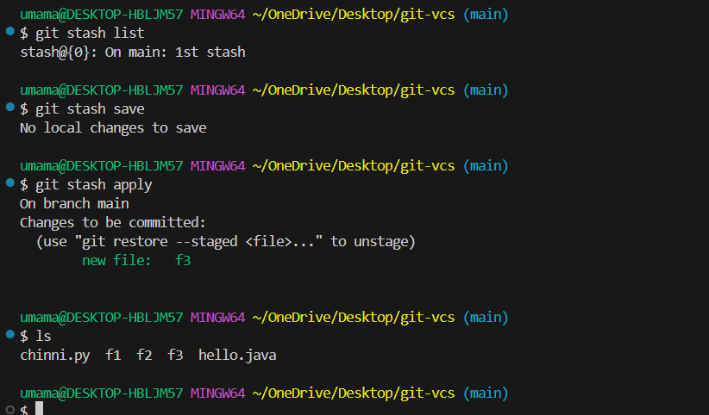

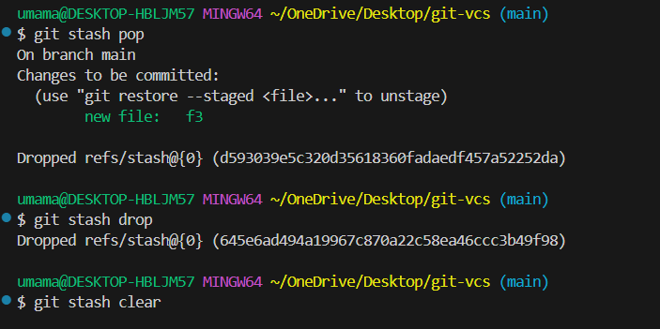

**⚔️ 13. Merge conflict:** A merge conflict occurs when Git cannot automatically merge changes because two branches modified the same part of a file differently. The developer must manually resolve the conflict before completing the merge.

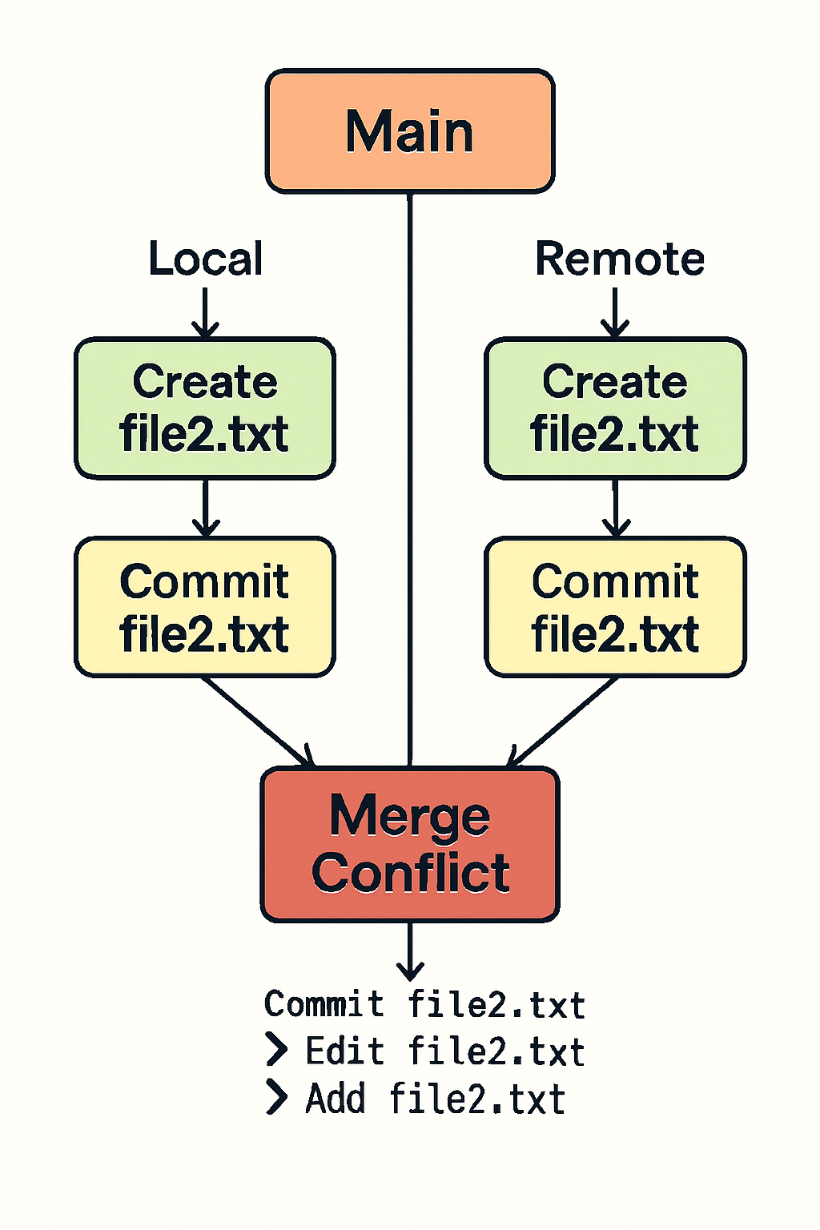

* Create file in repo and add some content and commit changes
* Now it local directory create file with same name created in repo.
* Now git add that file and commit it.
* Now when we push we get merge conflict.

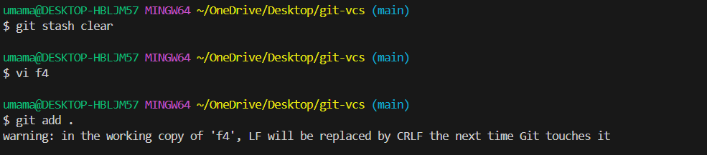

When we get merge conflict, we first pull remote repo after that, Open the file and remove unwanted data.

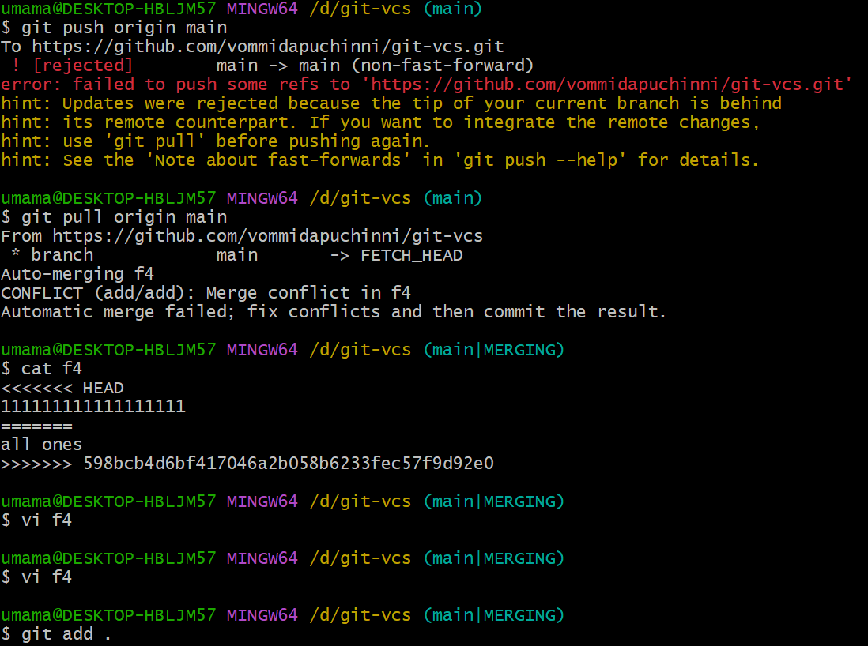

After that add that file and commit it.

Now push the file

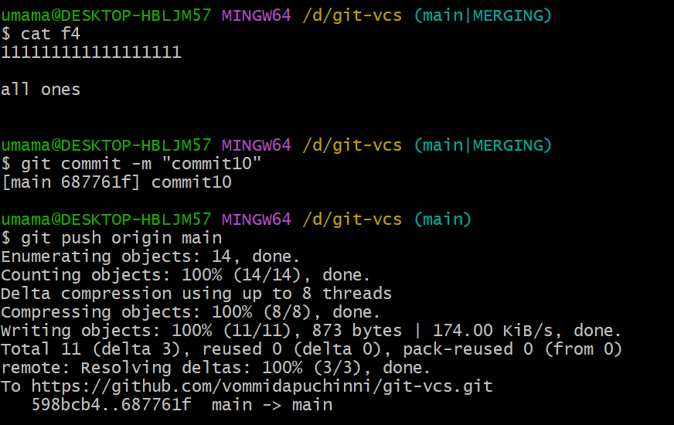

**🧬 14. Rebase** = move or replay commits from one branch on top of another.

Instead of merging, which creates a merge commit, rebase rewrites history so it looks like your work started from the latest commit in the target branch.

In simple terms:

* Merge = “combine both histories with all bumps.”
* Rebase = “lift my commits and put them on top of the other branch (clean history).”

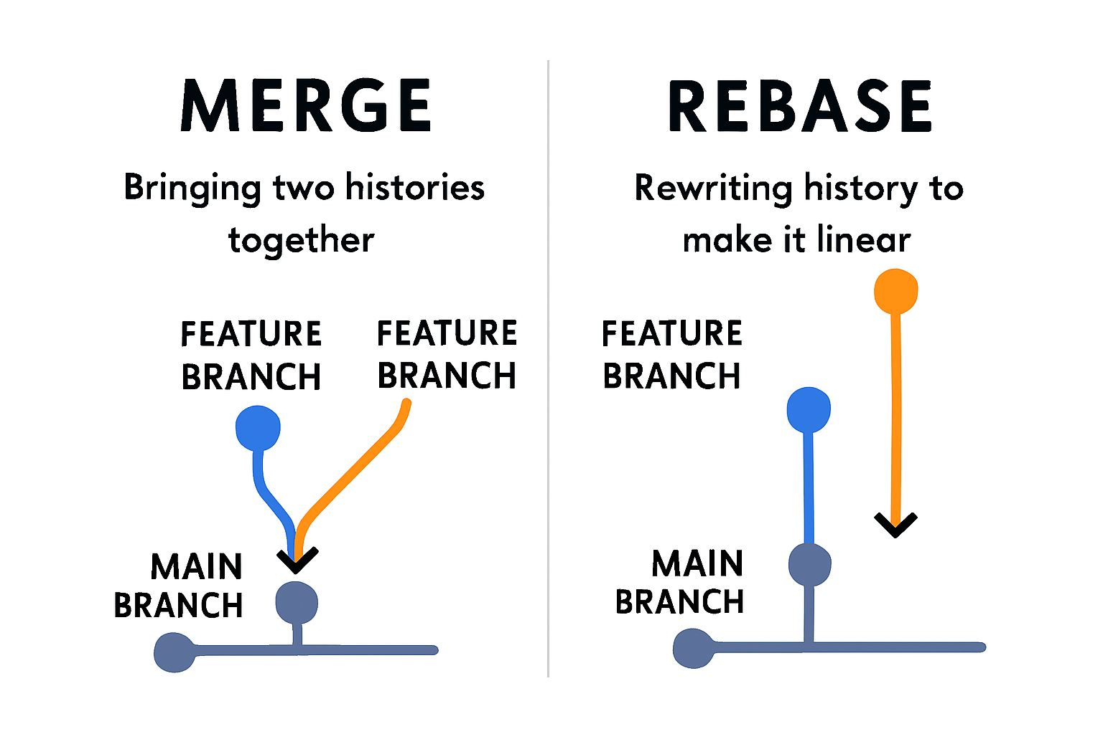

git log –oneline 🡪 get all logs in one line

Since I want to rewrite the last 2 commits (commit10 and commit): git rebase -i HEAD~2

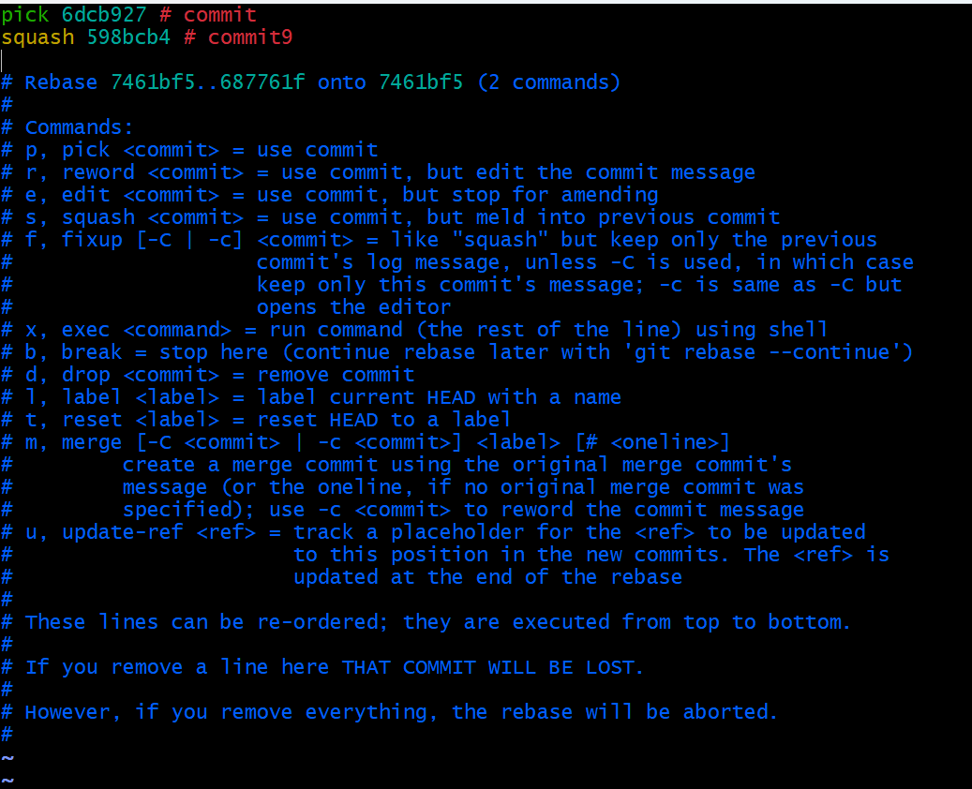

This means “combine commit10 into commit”

* If you want to drop commit9 completely: pick 6dcb927 # commit && drop 598bcb4 # commit9
* If you want to reword the message of commit9: pick 6dcb927 # commit && reword 598bcb4 # commit9

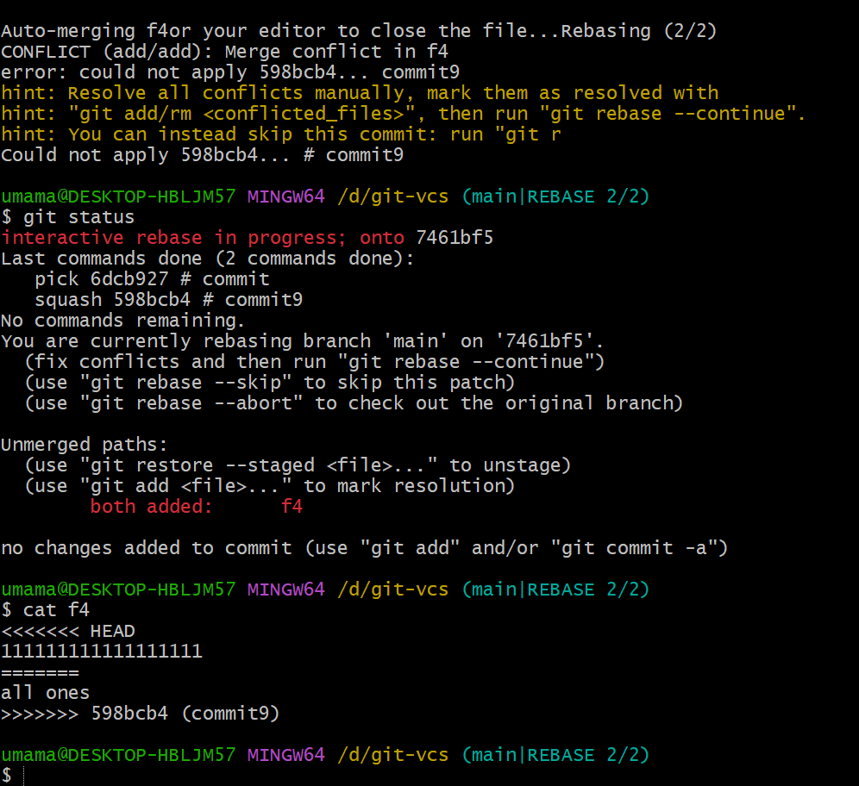

**Edit file and push it.**

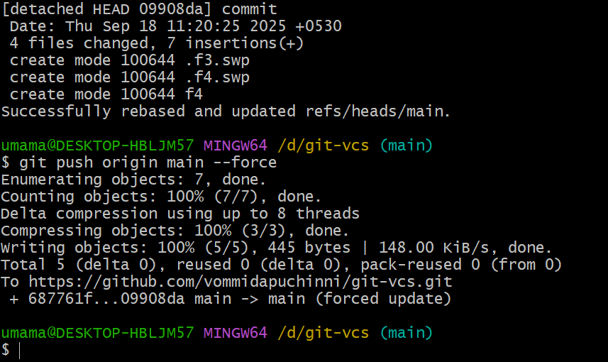

**📥 15. A Pull Request** is a feature in Git platforms like GitHub, GitLab, or Bitbucket that lets you propose changes made in one branch to be merged into another branch (usually main or develop).

* git checkout -b feature-branch
* echo "Some change" >> test.txt
* git add test.txt
* git commit -m "Add test file for PR"
* git push origin feature-branch

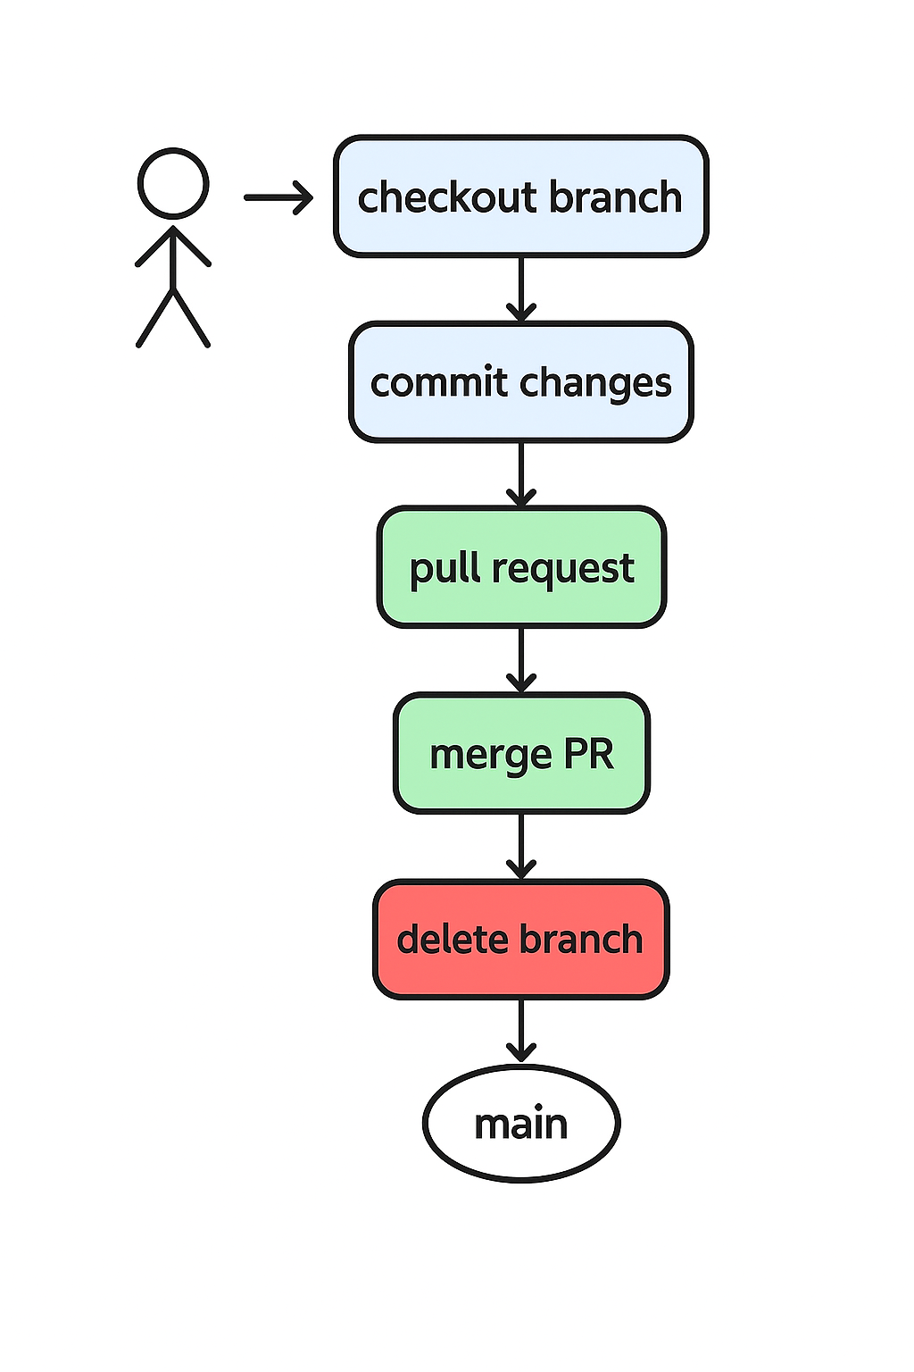

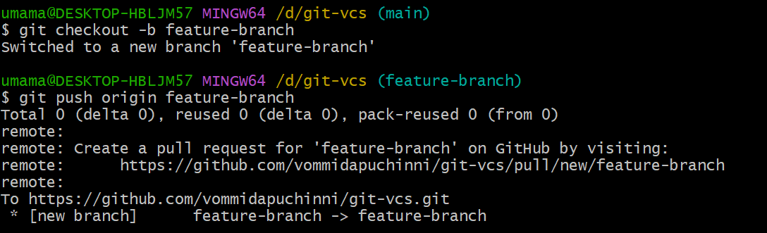

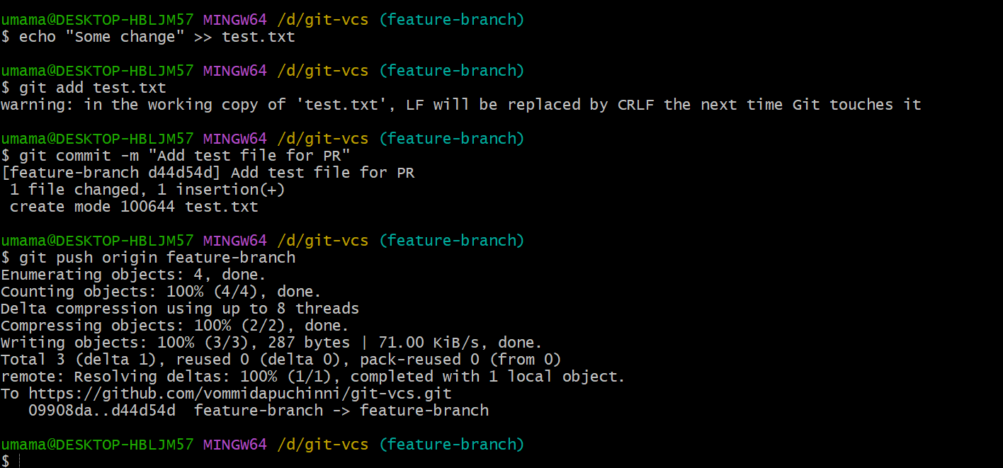

Go back to GitHub → Pull Requests → New pull request.

* Now you’ll see the changes from feature-branch compared to main.

Create the PR as usual.

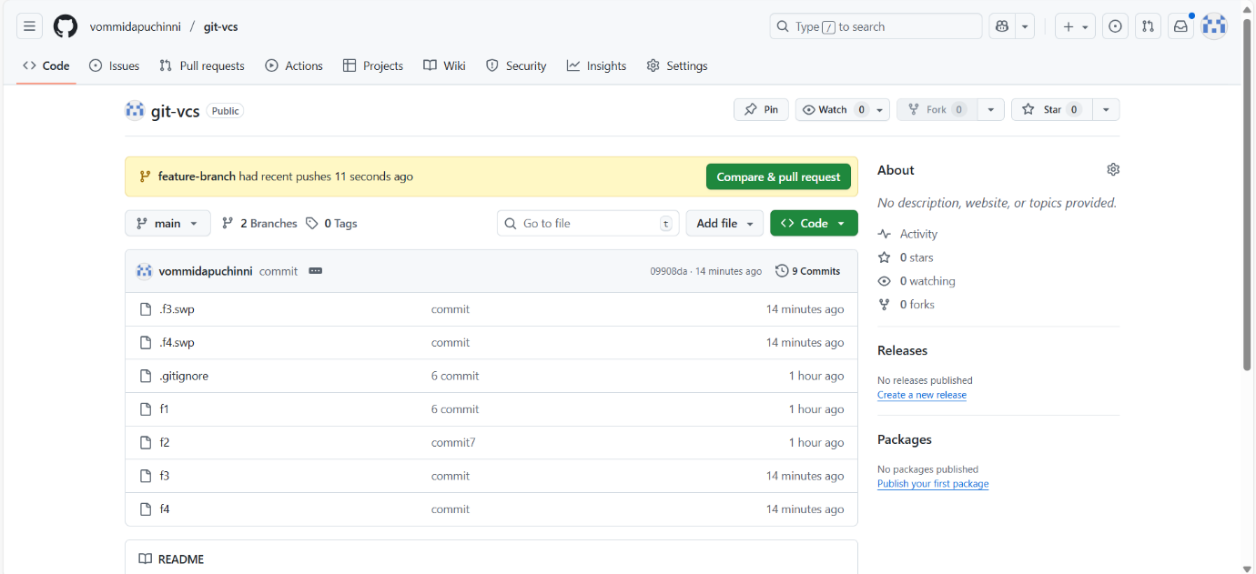

**Steps to create the PR**

* Title: Add test file for PR (or any descriptive title)
* Description: Explain what this PR does.
* Click Create Pull Request.

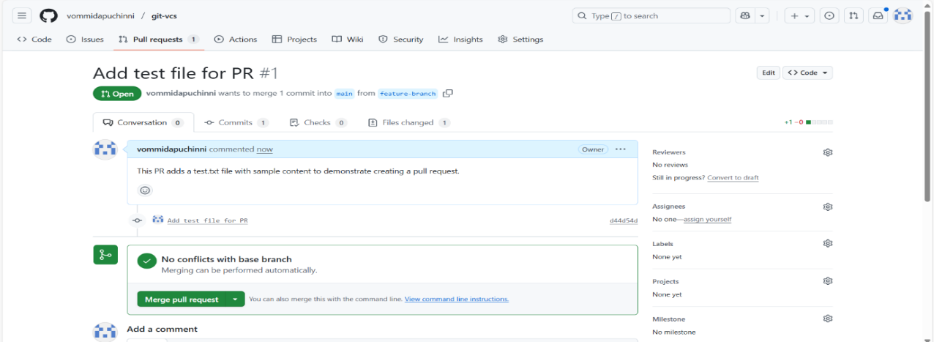

Click on merge pull request both branches will be merged

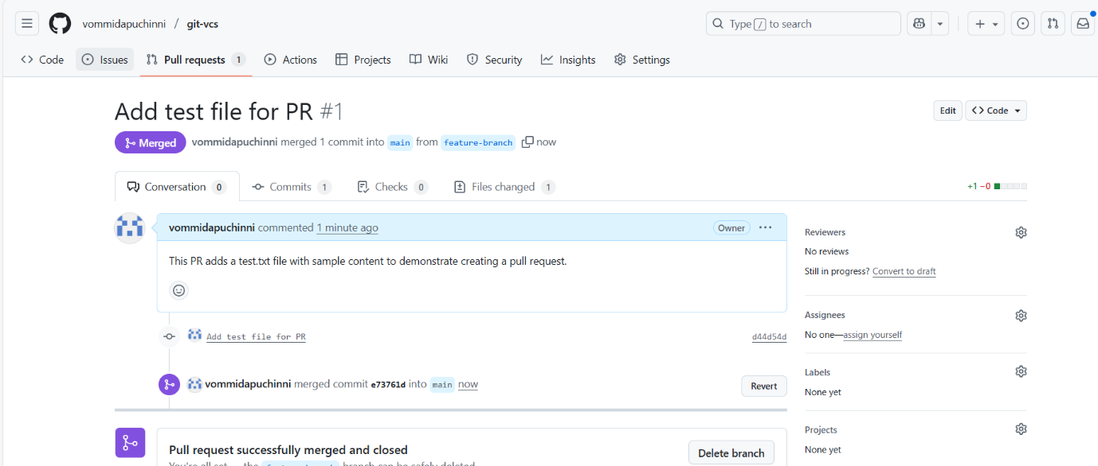

Delete branch in repo and local we use git push origin --delete branchname

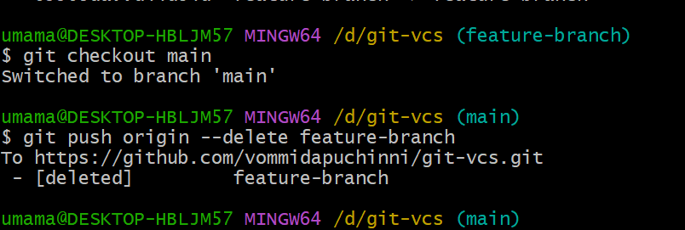

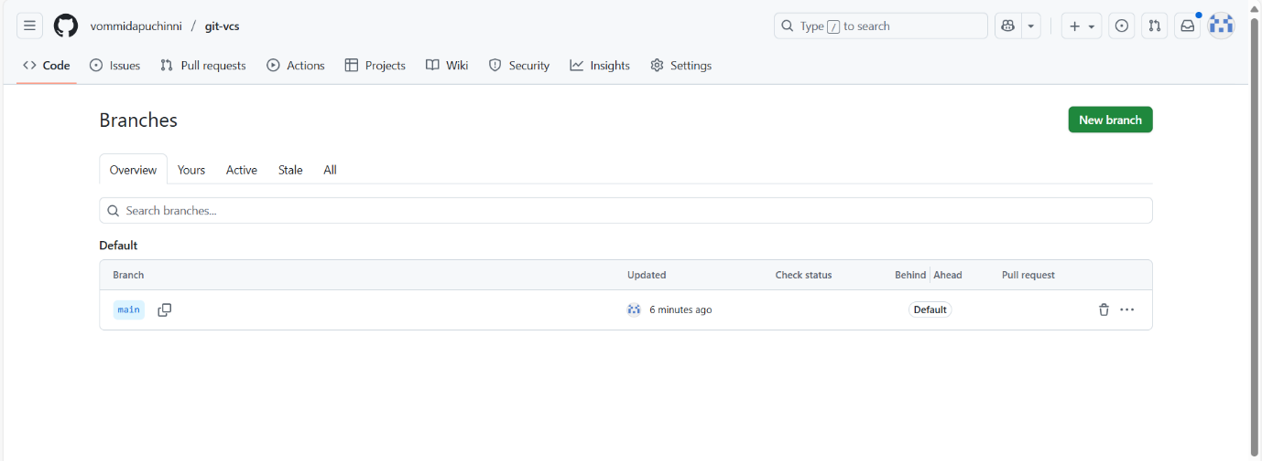

**🧰 16. Advanced topics:**

* 🪝Hooks: Automate actions on commits (.git/hooks/pre-commit)
* 🧪Bisect: Find bad commit: git bisect start
* 🧩Submodules: Repo inside a repo: git submodule add <url>
* 🏕️Worktree: Multiple working directories: git worktree add ../feature feature-branch